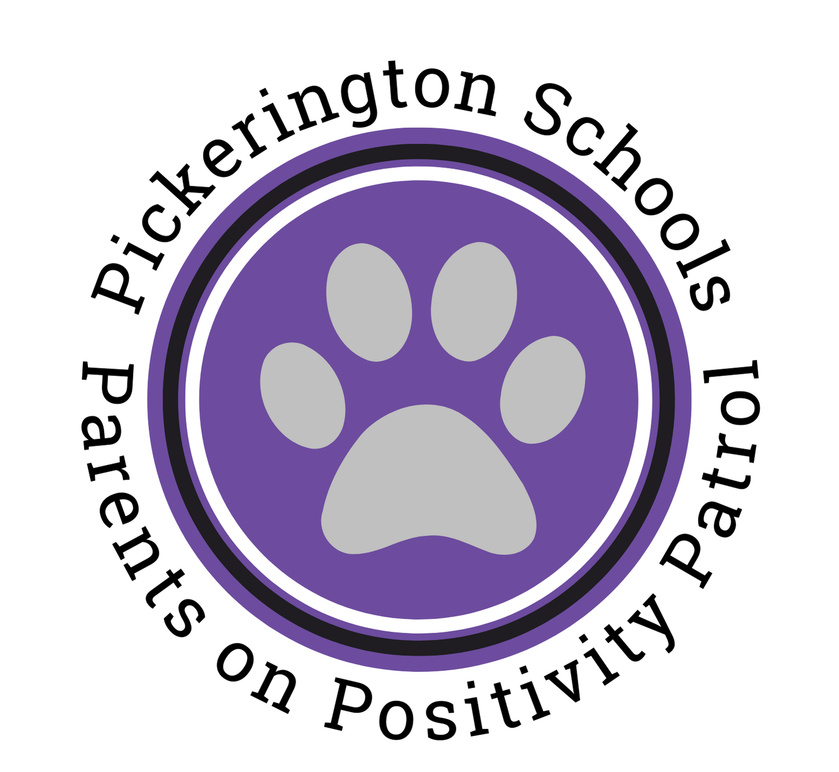
Pickerington Schools Parents on Positivity Patrol FAQ

1. What is POPP?
The acronym PoPP stands for Parents on Positivity Patrol. This program consists of parent volunteers in our schools. Parent volunteers play an essential role in modern education. They are great resources for teachers and solid support for the school community, but parent volunteers also demonstrate to their children and others that school is important and worth the time and effort. We have created this opportunity to engage parents in schools where their children attend. In PLSD, we value parents and families, and together we are the community. The purpose of PoPP is to ensure we are providing more caring adults in our buildings. In addition, our PoPP's spread positivity by building positive relationships with students and staff.

2. What does a typical day for a PoPP volunteer look like?
A typical day for a PoPP looks something like this:

PoPP signs in at the main office and picks up their PoPP vest and walkie-talkie.
The PoPP then heads to the area for patrol identified by the school administration. Their primary mission* is to be a positive presence in the building, sharing a friendly smile or a welcoming "Hello." The PoPPs work in pairs and can monitor halls, restrooms, and cafeteria areas.

*PoPP are NOT disciplinarians.

3. How did the program come to be at the high schools?
There was a parent meeting held at a local church last fall, and parents asked us to explore the possibility of parent volunteers at the high school level. So we did more than explore the opportunity; we started a pilot program at both high schools.

4. Has it made a difference? and if so how?
Yes, it has made a difference for our students, staff and parents. Our students look forward to the positive interactions with the PoPP. Our parents get a glimpse of school culture and become part of their student's educational experience, and our teachers and staff members look forward to seeing the PoPPs in the buildings.

5. How many volunteers do you need and how many hours are they required to work?
We would love to have at least 100 PoPPs; the hours depend on the school's needs and the parent's schedules. For example, some parents can only participate on Tuesday and Thursdays from 10-12, and others can participate all day.

6. How do our high schools and junior highs benefit from this program?
Karen Mapp's research out of Harvard and Joyce Epstein's work from Johns Hopkins University have shown that children of a school volunteer make better grades and perform better on tests. They're also better behaved, have better attendance, and are more likely to graduate and continue their education. In addition, this program solidifies the ecosystems of support for students and improves relationships and engagement with parents.

7. How do people become POPP volunteers?

- Email PoPP@plsd.us.
- Complete the PoPP Volunteer Application.
- Complete a criminal background check.
- Actively participate in PoPP Orientation & Training.
- Be ready to make a positive difference in our schools!

